EXP 5 : CALCULATION AND VERIFICATION OF FREQUENCY DEVIATION AND MODULATION OF FM SIGNALS USING MATLAB SIMULATION

SOFTWARE USED : MATLAB SOFTWARE

CODE :
clc; clear; close all

fm=1e3; fc=10e3; Am=1; Ac=1;
Df=5e3; % Frequency deviation
beta=Df/fm; % Modulation index
Fs=1e5; t=0:1/Fs:2e-3;

m=Am*cos(2*pi*fm*t);
c=Ac*cos(2*pi*fc*t);
FM=Ac*cos(2*pi*fc*t+2*pi*Df/fm*sin(2*pi*fm*t));

subplot(3,1,1),plot(t,m),grid on
title('Message Signal')

subplot(3,1,2),plot(t,c),grid on
title('Carrier Signal')

subplot(3,1,3),plot(t,FM),grid on
title('FM Signal')

fprintf('Frequency Deviation = %.0f Hz\n',Df);
fprintf('Modulation Index = %.2f\n',beta);
fprintf('Maximum Frequency = %.0f Hz\n',fc+Df);
fprintf('Minimum Frequency = %.0f Hz\n',fc-Df);

MODEL GRAPH :
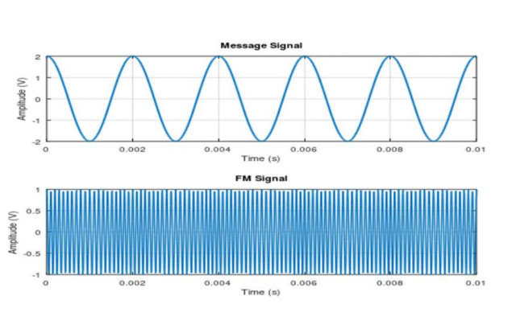
RESULT:
